1. Provision, manage and deploy Secure Sockets Layer SSL: a transporter security in the short term you may call it as SSL TLS certificate for use with AWS services.
2. These SSL or TLS certificates are used to secure Network communications and establish the identity of the site over the Internet.
3. It removes the time-consuming Manual process of purchasing, uploading and renewing SSL/ TLS certificates.
4. With certificate Manager, you can quickly request a certificate, deployed on AWS services like ELB, CloudFront… and let the certificate Manager handle your certificate renewals.
5. SSL/TLS certificates provision choose certificate manager are free.you don't have to pay even a single penny if you get these certificates issued .
6. you pay only for AWS resources you create to run your own application in a nutshell you can generate free SSL or TLS certificates from AWS certificated manager and you can upload them to ELB or the CF distributions.

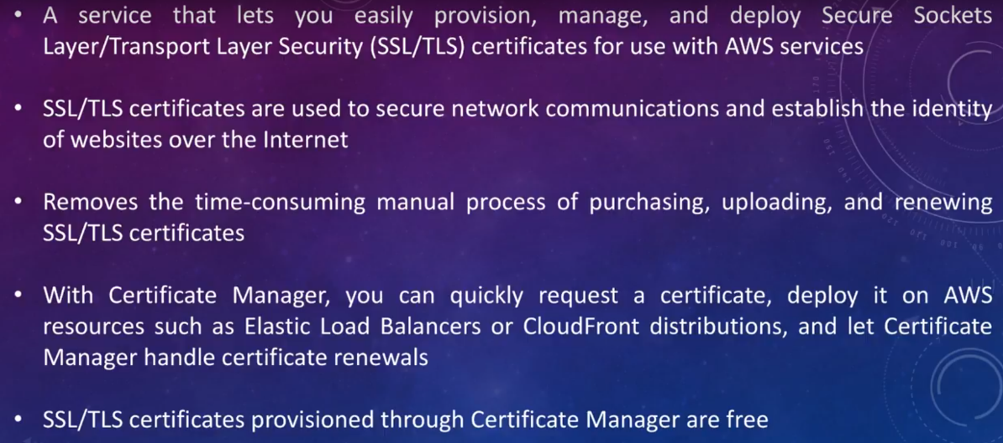

These certificates help to make your website secure and it encrypt the communication from the end users to your front-end web applications that you deploy in the Amazon Web Services cloud.

**DEMO**

1. 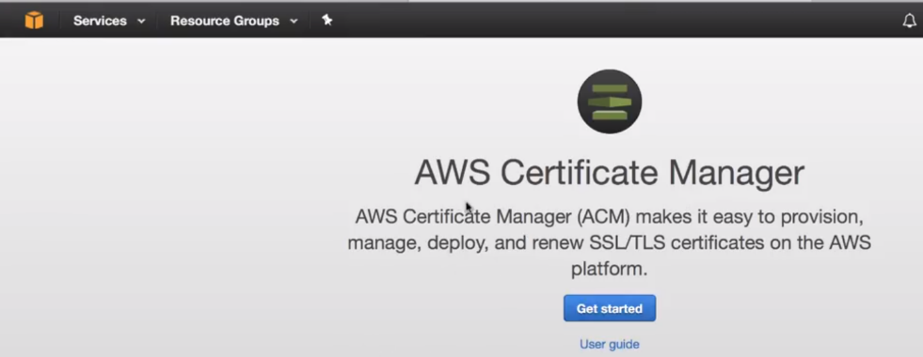

On Dashboard, you can see: AWS certificate manager or ACM makes it easy to provision, manage and deploy and renew SSL/TLS certificates on AWS platform.

1. first thing that I need to perform is to **define the domain name** for which I'm trying to upload or trying to generate a certificate.

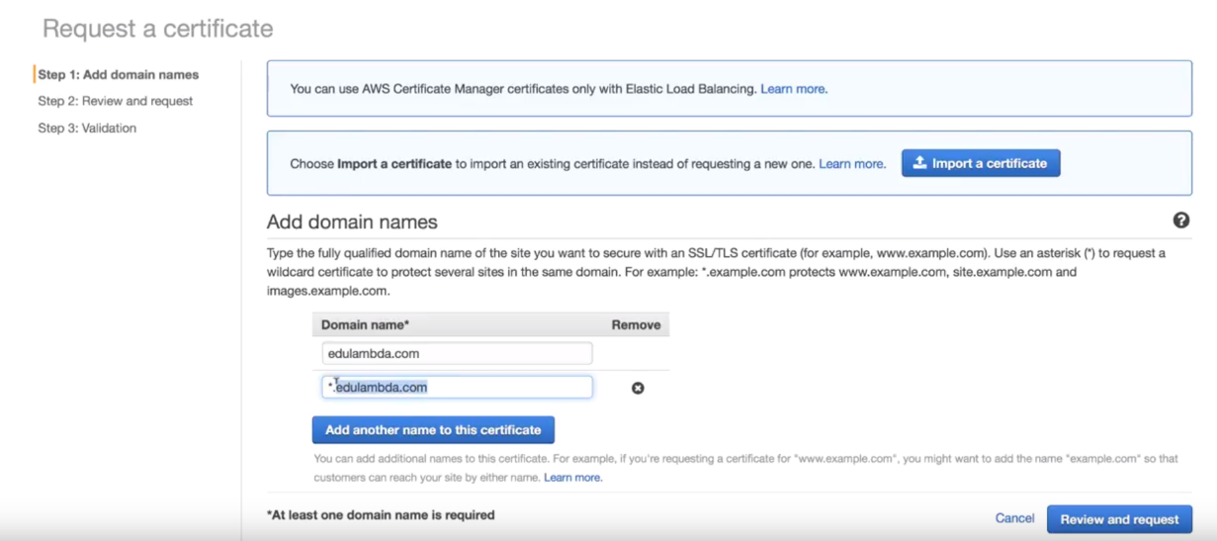

just type in my domain name AND click on add another name to this certificate…

Add include *.(asterisk followed by dot) then I specify my domain name..

**Why I need to define wild-card * dot followed by domain name???**

I'm doing so to include my subdomains as approve the certificate for all my sub domains.

**For example** dark.example.com, male.example.com, Drive.example.com ..

I want to approve the certificate from a domain and all its associated sub domains…

3.)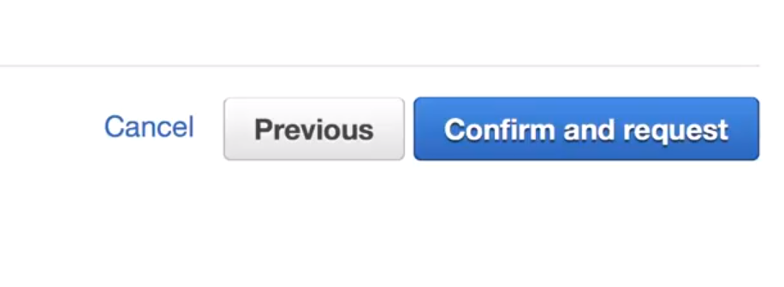

confirm a request ..

4.)I am supposed to receive and validation email because I need to approve that I'm going to issue a certificate for my domain.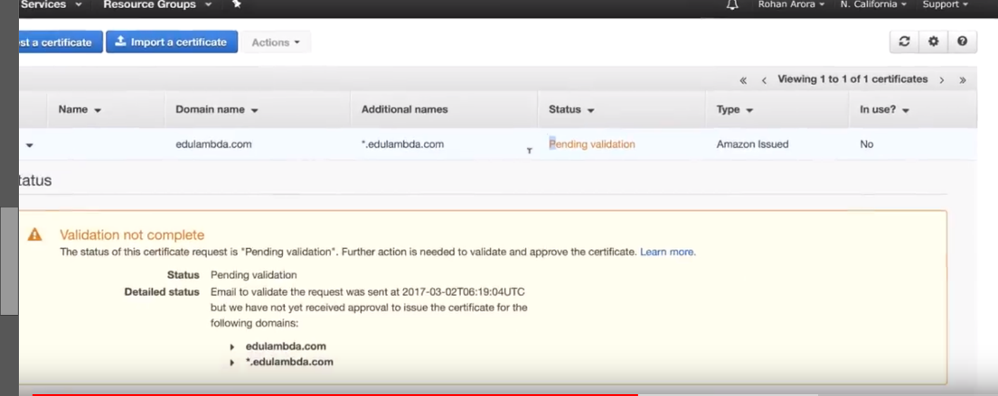

Status is showing pending validation…

Verfiy email..

5.) Status is showing still pending ..Still I validated ..Do it twice(bug…Delete and start again)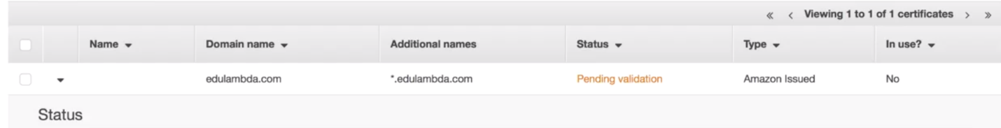

**DEMO-2:**

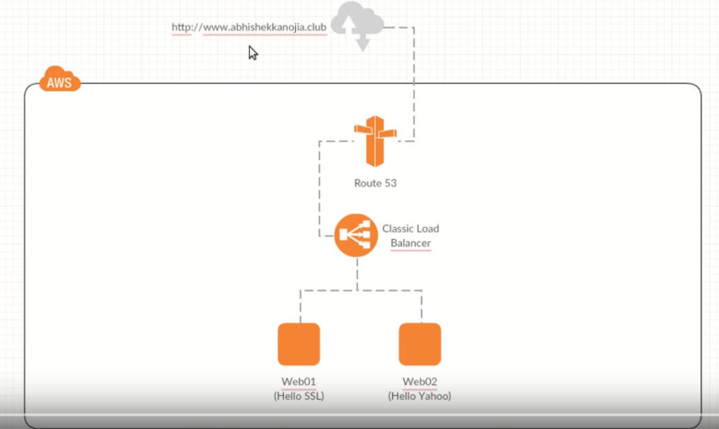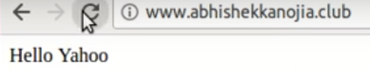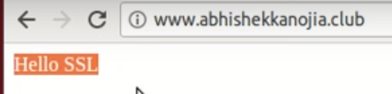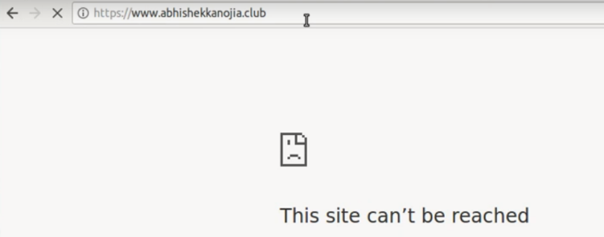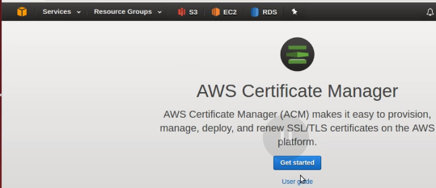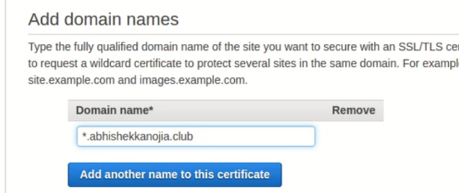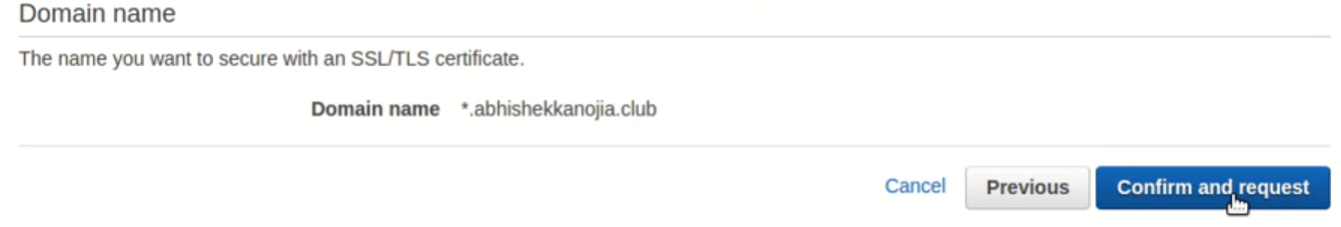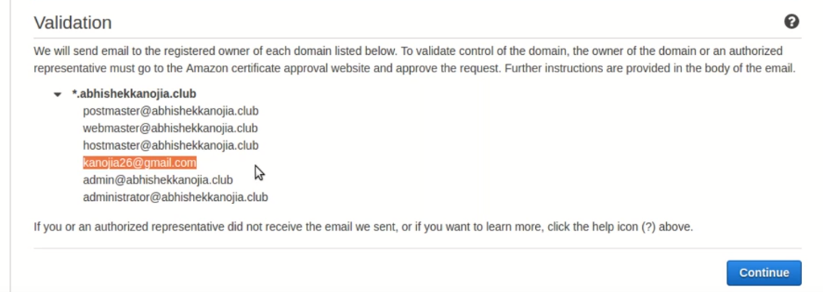

**EMAIL sent to registered owner of doamin**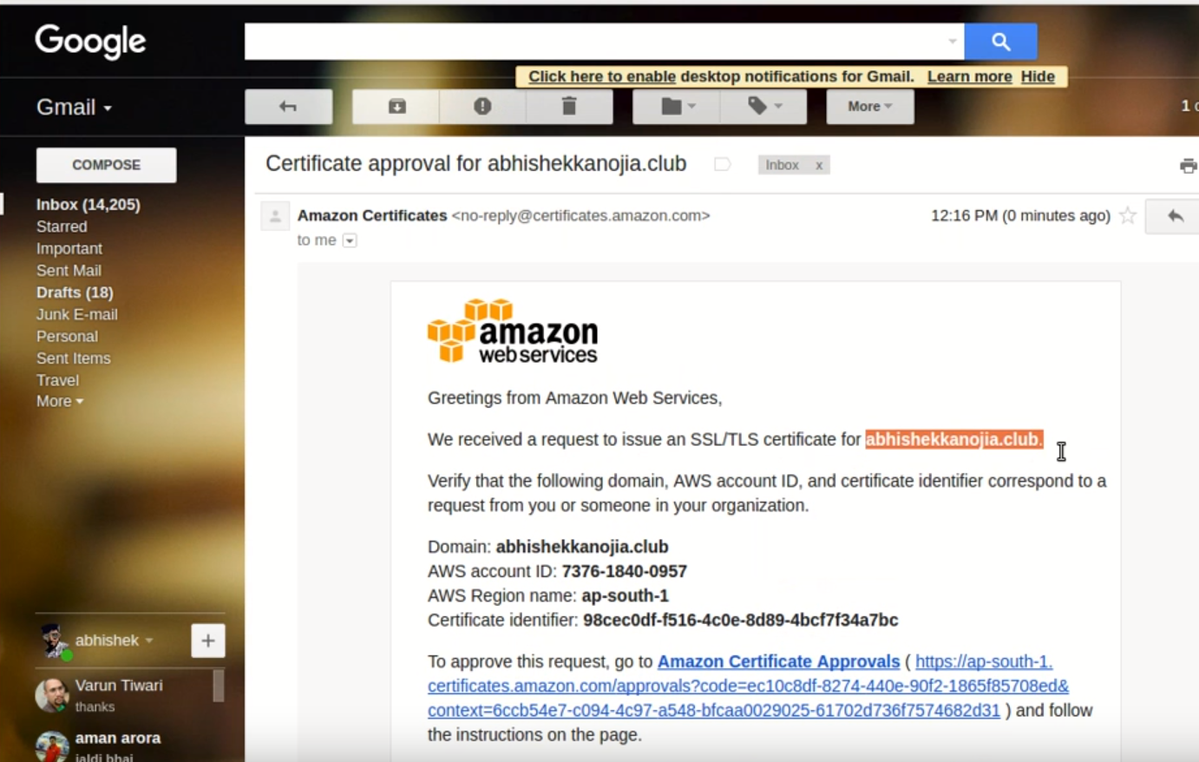

**1.)GOTO ELB:**

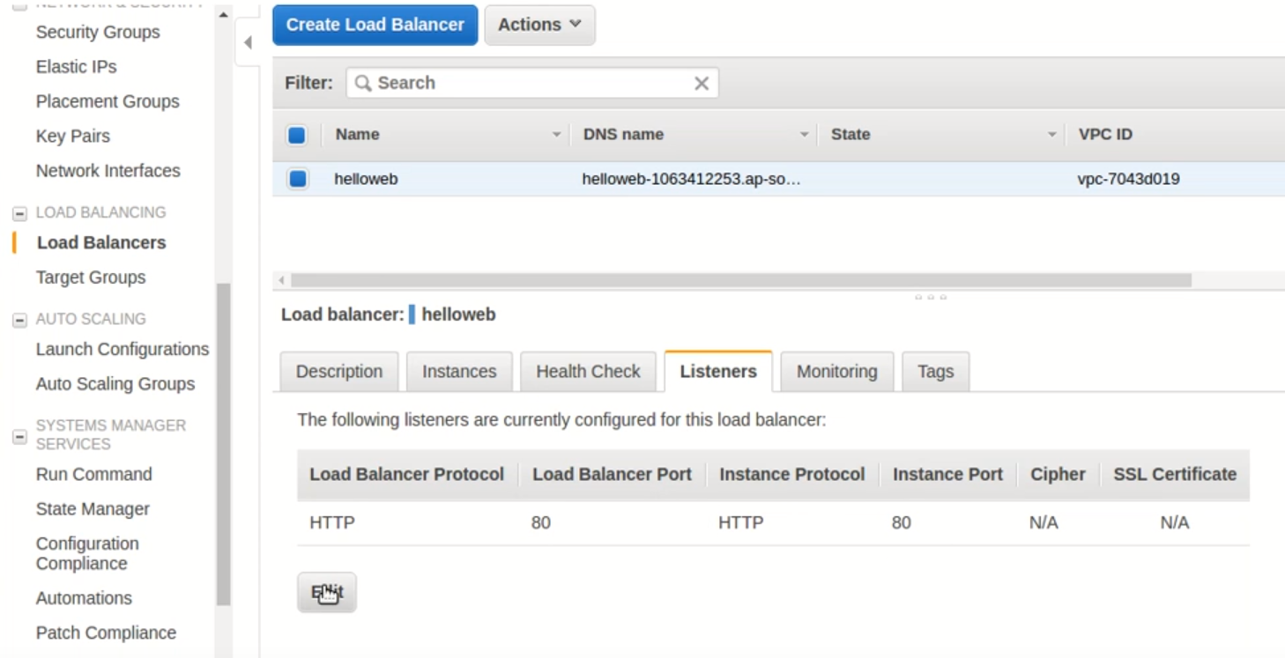

**2)ADD HTTPS-🡪SSL CERTIFICATE CHANGE**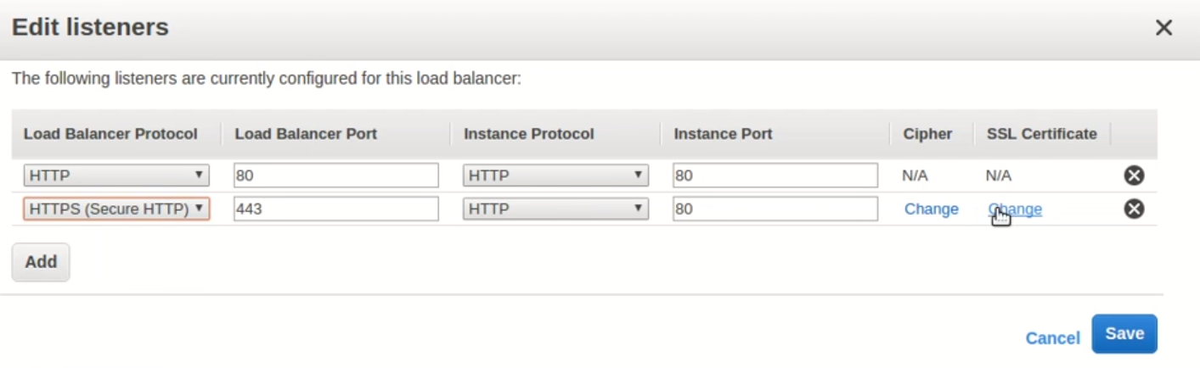

**3.)Upload cert**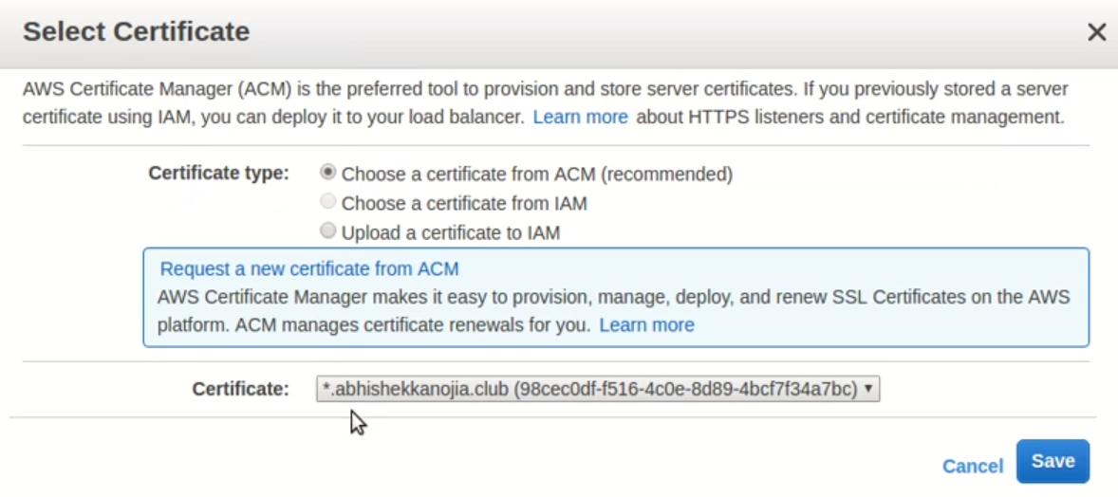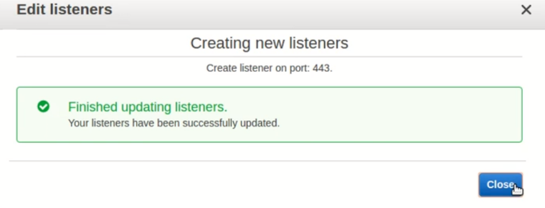

**4.) Goto SecurityGroup🡪add https rule**

**5.)**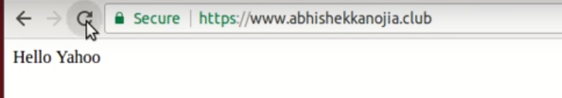

**CloudFront:**

1. **Goto Cloudfront, and click on distribution**

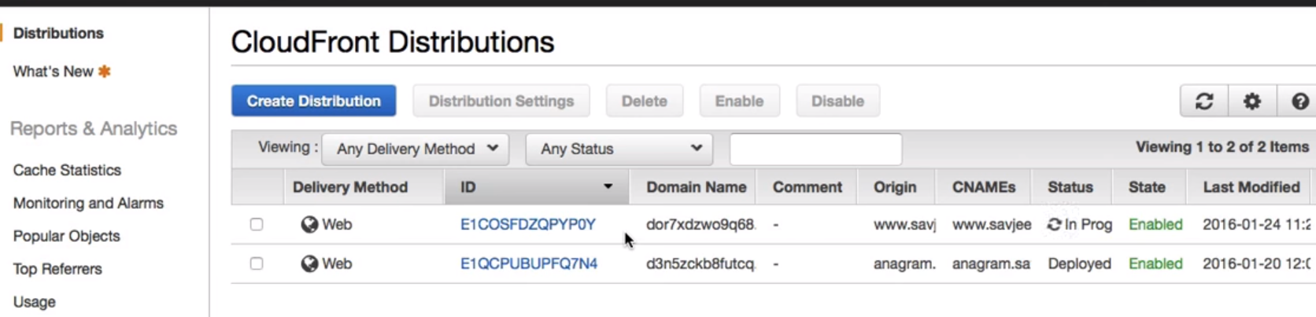

**2.)Goto General-🡪edit**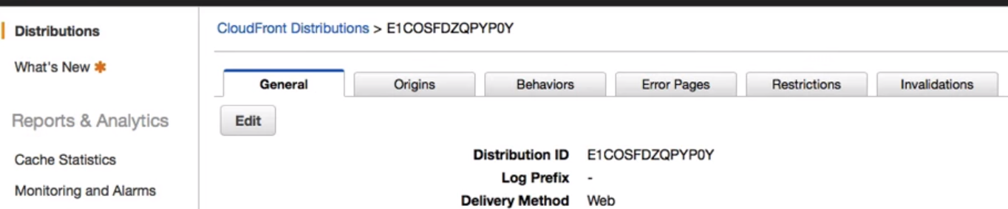

**3.) Select custom SSL certificate…**

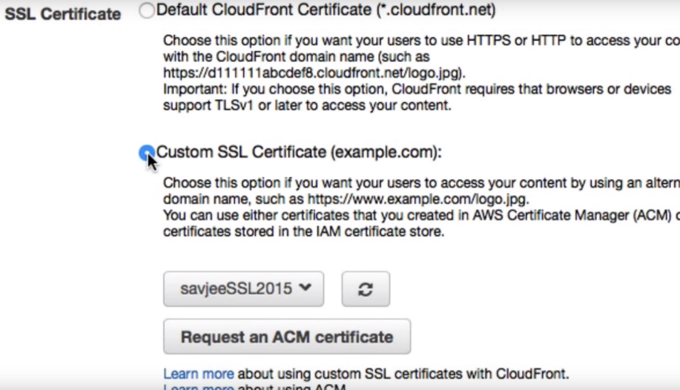

1. **We can also verify cert is signed by Amazon.**

